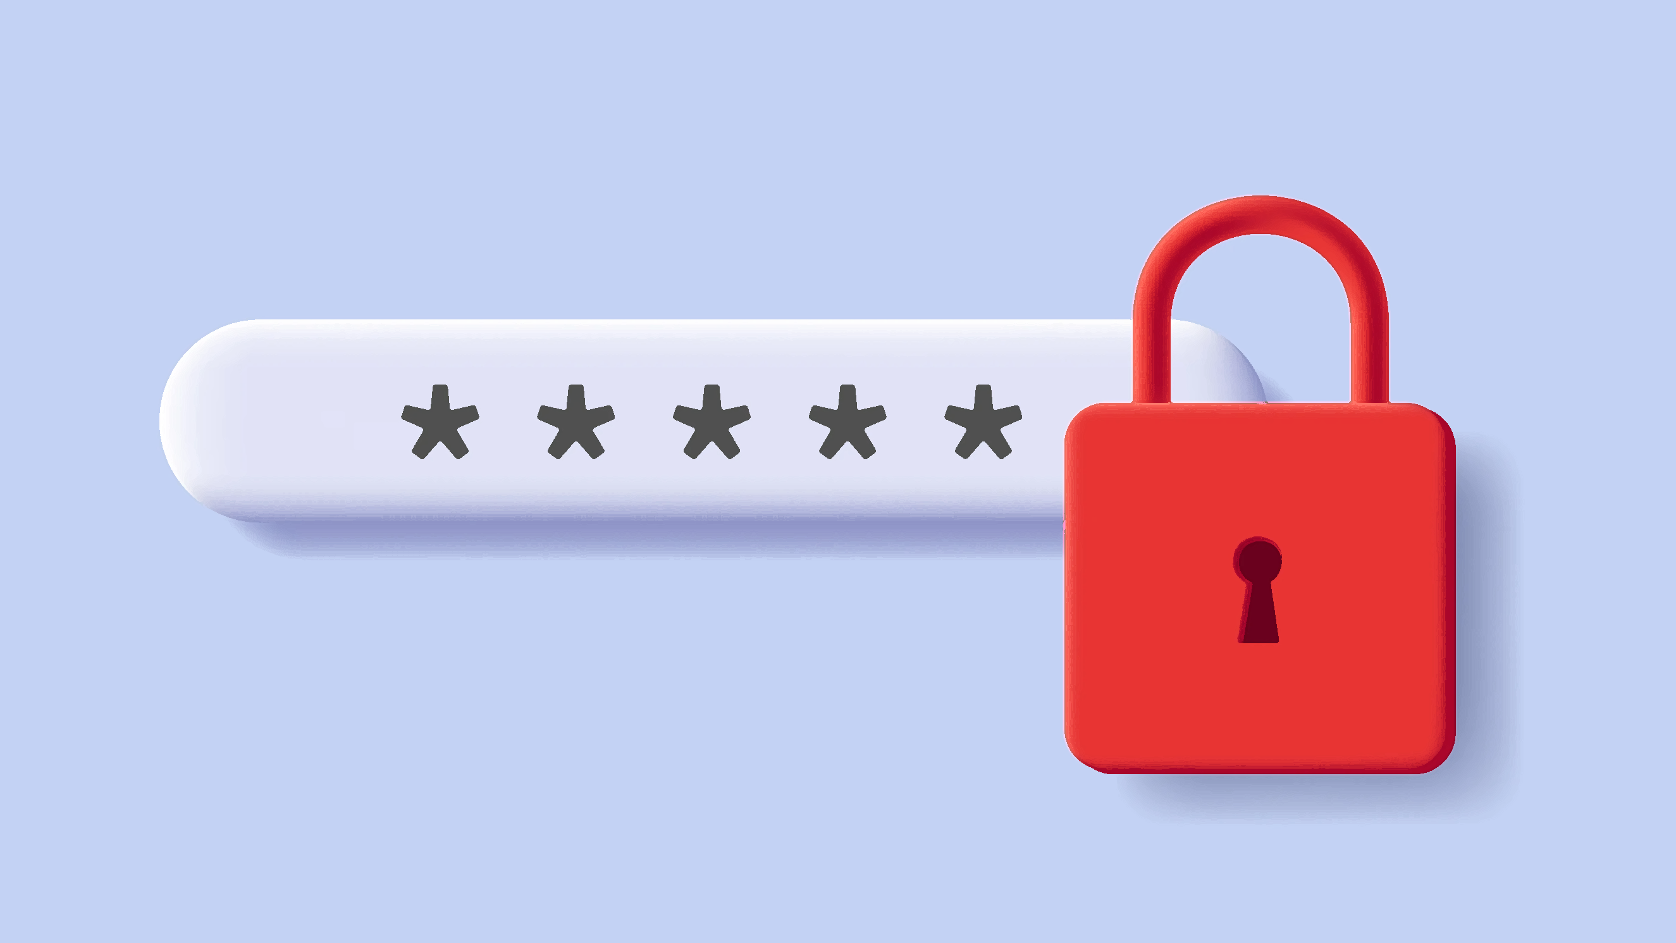
Password Manager

ACKNOWLEDGEMENT

I would like to thank God Almighty being my pillar of support during challenging times and for guiding me and giving me the strength to persevere.

I also wish to express my gratitude to CBSE Board for initiating this project and giving me an opportunity to improve my knowledge and practical skills on Python
Programming Language and RDBMS.

I thank Principal Rev. Dr. Fr. Varghese Kachappilly CMI and Vice Principal Mrs.Vinitha Mendez for their encouragement and unfailing support that helped me to
complete my project.

I sincerely thank Mrs. Mariama Thomas, faculty Sacred Heart CMI Public School for challenging me to reach my highest potential. Her timely suggestions and her keen interest and enthusiasm have enabled me to complete my project.
Finally I would like to thank my parents who have helped me with their valuable suggestions and guidance which has aided me in various phases of the project.

CONTENTS
1. Project at a Glance
2. System Requirements & Specifications
3. Data Dictionary
4. Source Code
5. Outputs
6. Bibliography

PROJECT AT A GLANCE
This Python-based password manager, powered by the MySQL connector, offers a robust solution for users seeking enhanced digital security and convenience. The "Sign Up" option allows users to create a new account by specifying a unique username and password. These credentials are securely stored within a MySQL database, ensuring the utmost account security.
Once registered, the "Login" feature provides authentication, enabling users to access a range of password management capabilities. These include the ability to securely save and retrieve passwords, display a comprehensive list of saved credentials, update stored records, and delete passwords as needed.
Furthermore, the "Exit" option ensures that users can safely terminate the program while also gracefully closing the database connection, guaranteeing data integrity. This comprehensive password manager empowers users to maintain and access their sensitive information with confidence and ease, ultimately strengthening their digital security posture.

SYSTEM REQUIREMENTS & SPECIFICATIONS
Hardware Specifications
- System – 32-bit operating system
- Processor – AMD Sempron™145 Processor 2.80 GHz
- Speed – 2.80 GHz
- Memory – 2.00 GB
- Hard Disk -70.3 GB
Software Specifications
- Operating System – Windows 10
- Development Environment – IDLE
- Language Used – Pyhton
- Front End – Python
- Back End – Mysql

DATA DICTIONARY
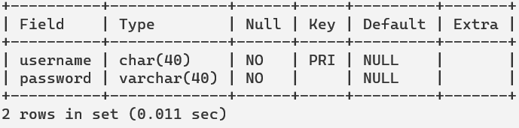
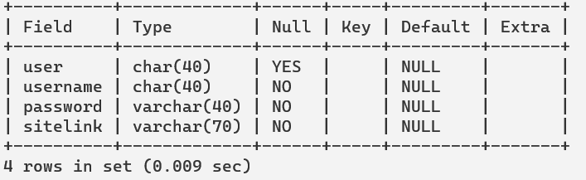

SOURCE CODE
#PASSWORD MANAGER

#Importing
import mysql.connector as mc
from tabulate import tabulate
con=mc.connect(host="localhost",user="root",password="root")
cur=con.cursor()

global user,passw

# TABLE CREATION
try:
cur.execute("create database passmang")
cur.execute("use passmang")
cur.execute("create table Users(username char(40) primary key NOT NULL,password varchar(40) NOT NULL)")
cur.execute("create table Details(user char(40),username char(40) NOT NULL,password varchar(40) NOT NULL,sitelink varchar(70)NOT NULL)")
con.commit()
except:
cur.execute("use passmang")
pass

# Create a new user account
def create_user(user,passw):
values=(user,passw)
cur.execute("INSERT INTO Users (username, password) VALUES (%s,%s)",values)
con.commit()
print("Account created.")
print("\n")

# Check if the user exists and the password is correct or not
def login_user(username, password):
cur.execute("SELECT * FROM users WHERE username = %s AND password = %s", (username,password))
user1=cur.fetchone()
if user1!=None:
print("Login Successful.")
return True
else:
print("Login failed. Invalid username or password.")
print("\n")

# To save a Password.
def save_pass():
userna=input("Please enter the Username : ")
passw=input("Please enter the Password : ")
Website=input("Please enter the Website link : ")
To=(user,userna,passw,Website)
cur.execute("insert into Details value(%s,%s,%s,%s)",To)
print("Username, Password and Website saved. ")
con.commit()
print("\n")
#To get a password.
def get_password(website):
select_query = "SELECT username,password,sitelink FROM Details WHERE sitelink=%s"
value = (website,)
cur.execute(select_query, value)
L=cur.fetchall()
if L==[]:
print("Website not found.")
else:
print(tabulate(L,headers=["Username", "Password","Website"],tablefmt="fancy_grid"))
print("\n")
# Display passwords using tabulate.
def display_passwords():
wewo=(user,)
cur.execute("select * from Details where user=%s",wewo)
password=cur.fetchall()
print(tabulate(password,headers=["User_Id","Username", "Password","Website"],tablefmt="fancy_grid"))
print("\n")

# To delete a password.
def delete_password():
website=input("Please enter Website link : ")
w=(website,user)
cur.execute("DELETE FROM Details WHERE sitelink=%s and user=%s",w)
con.commit()
print("Username and Password of the Website is deleted.")
print("\n")

# To update Username.
def update_username():
A=input("Enter current Username : ")
newuser=input("Enter the new Username : ")
Win=(newuser,A)
cur.execute("UPDATE Details SET username=%s WHERE username=%s",Win)
print("Username updated for the Website.")
print("\n")

#To update Password.
def update_password():
B=input("Enter the Username of the account : ")
C=input("Enter the current Password of the account : ")
newpassword=input("Enter the new Password : ")
Wi=(newpassword,B,C)
cur.execute("UPDATE Details SET password=%s WHERE username=%s and password=%s",Wi)
print("Password updated for the Website .")
print("\n")
# To update Sitelink.
def update_sitelink():
D=input("Enter the Username of the account : ")
E=input("Enter the Password of the account : ")
newsitelink=input("Enter the new Website : ")
N=(newsitelink,D,E)
cur.execute("UPDATE Details SET sitelink=%s WHERE username=%s and password=%s",N)
print("Website updated for the Website .")
print("\n")

while True:
print("\nᆞPᆞAᆞSᆞSᆞWᆞOᆞRᆞDᆞᆞᆞMᆞAᆞNᆞAᆞGᆞEᆞRᆞᆞᆞMᆞEᆞNᆞUᆞ ")
print("")
print("1- Sign Up")
print("2- Login")
print("3- Exit")
choice=int(input("Enter your Choice(1/2/3) : "))
print("\n")
if choice==1:
user=input("Enter Username : ")
passw=input("Enter Password : ")
create_user(user,passw)
print("User created successfully!")
elif choice==2:
username=input("Enter your Username : ")
password=input("Enter your Password : ")
print("\n")
L=login_user(username, password)
if L==True:
while True:
print("---Password Manager---")
print("1-Save a password.")
print("2-Retrieve a password.")
print("3-View all Username ,Password and Site link.")
print("4-Update the Records.")
print("5-Delete a password.")
print("6-Exit.")
ch=int(input("Please enter your Choice(1/2/3/4) : "))
print("\n")
if ch==1:
save_pass()
elif ch==2:
website = input("Please enter website link to retrieve password : ")
get_password(website)
elif ch==3:
display_passwords()
elif ch==4:
print("1-Change Username.")
print("2-Change password.")
print("3-Change Site Link.")
print("\n")
ch2=int(input("Enter you choice(1/2/3) : "))
print("\n")
if ch2==1:
update_username()
if ch2==2:
update_password()
if ch2==3:
update_sitelink()
elif ch==5:
delete_password()
elif ch==6:
print("You have logged out.")
print("\n")
break
elif choice==3:
cur.close()
con.close()
print("You have exited the program.")
break

OUTPUTS
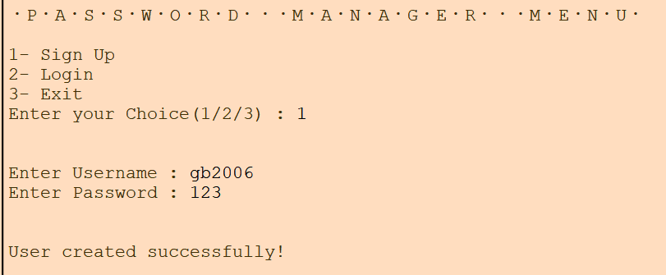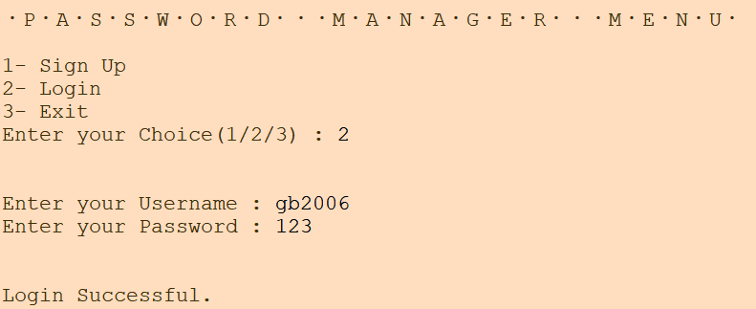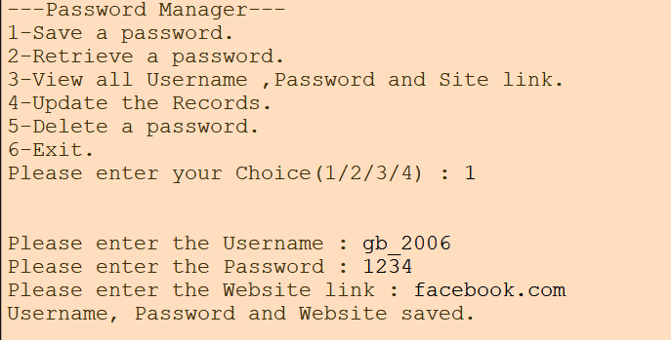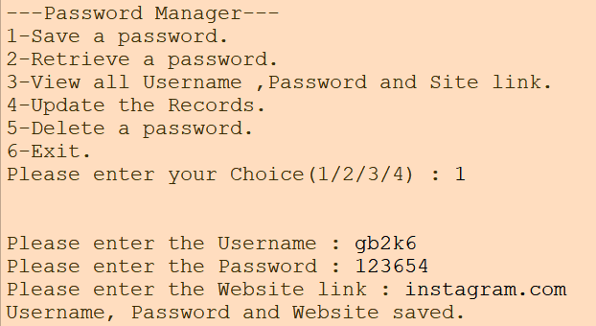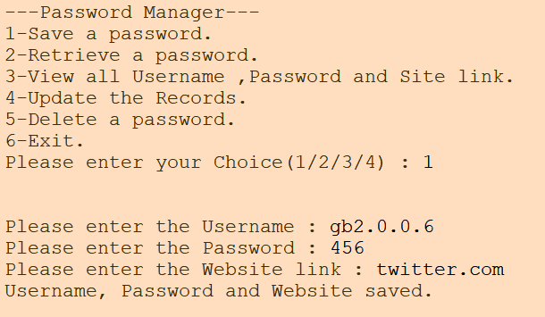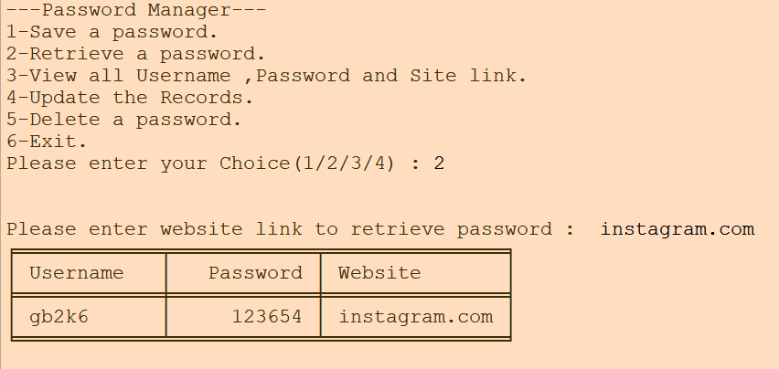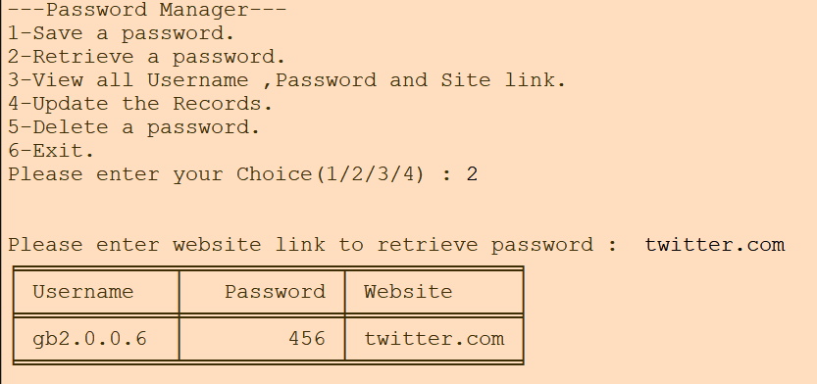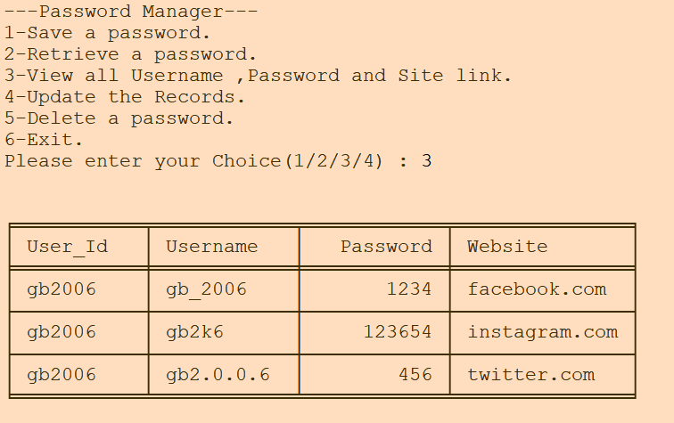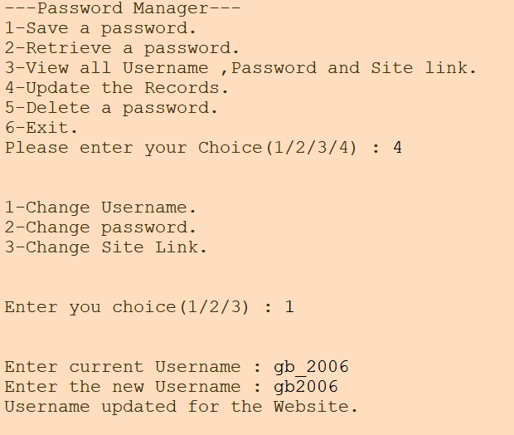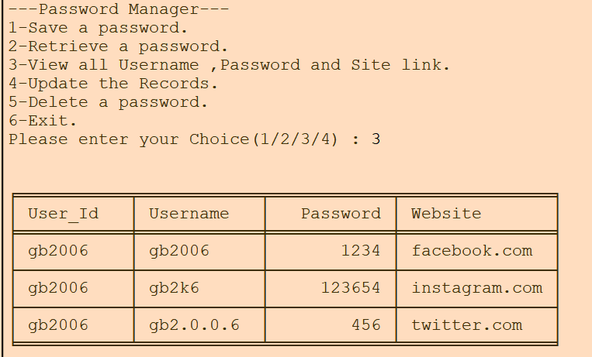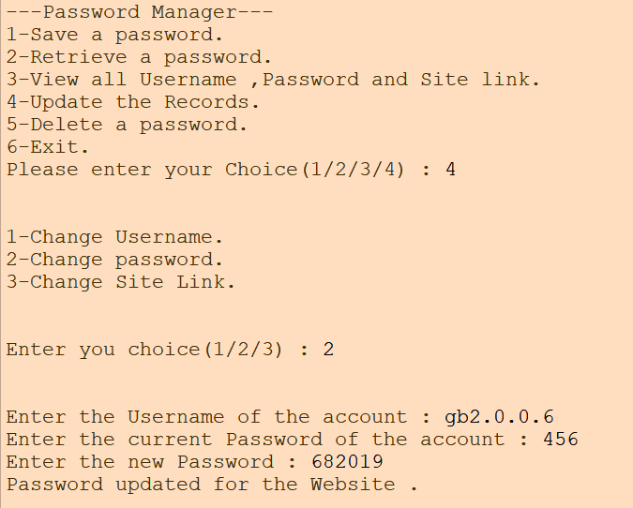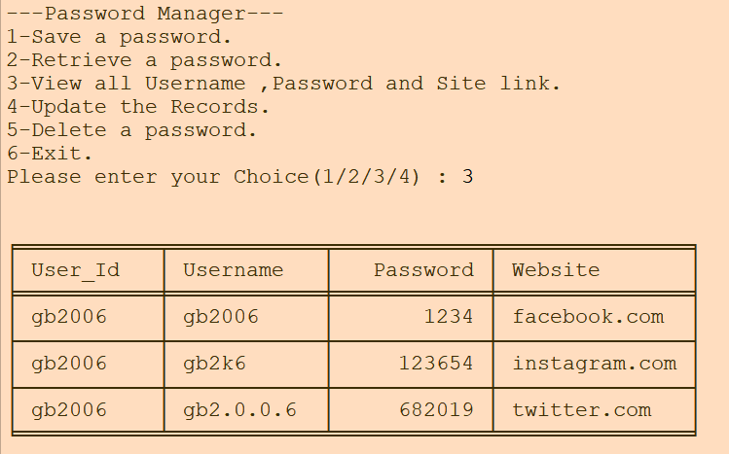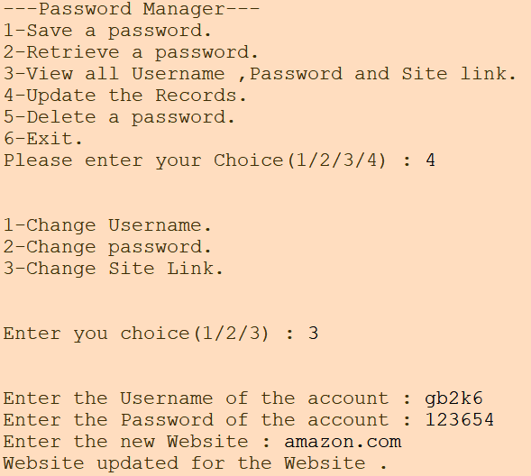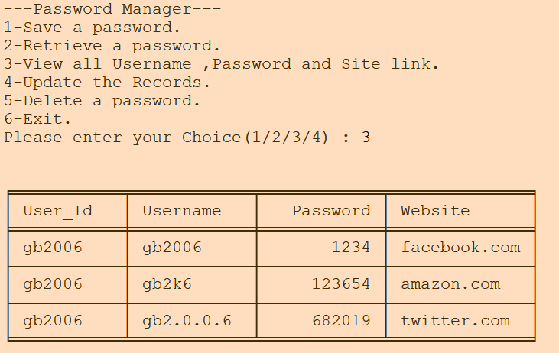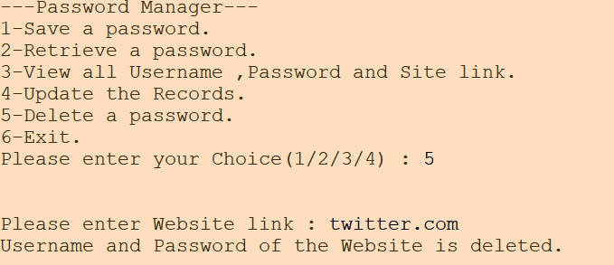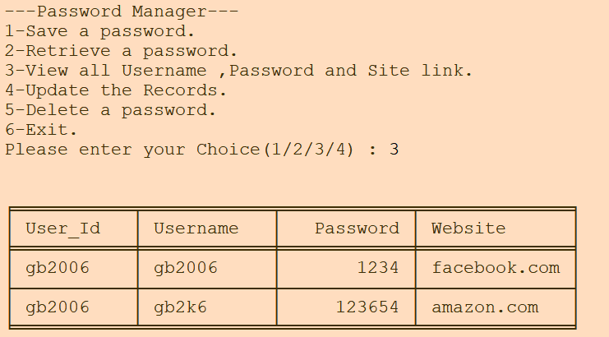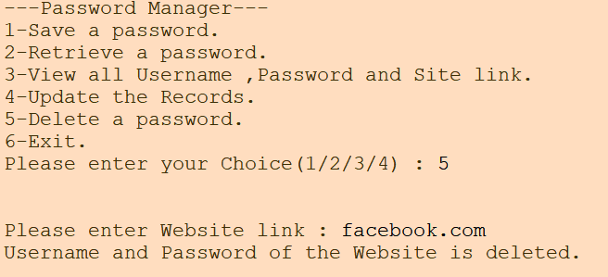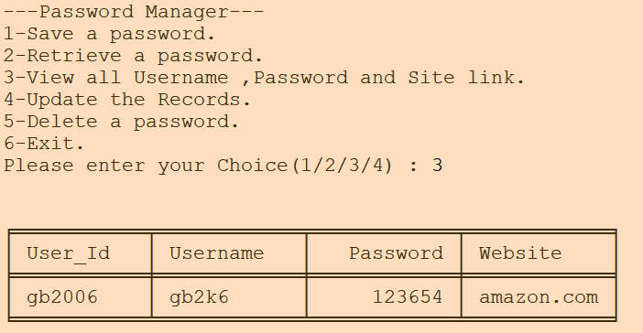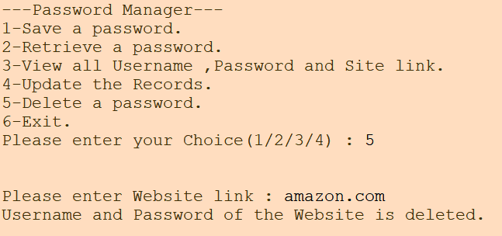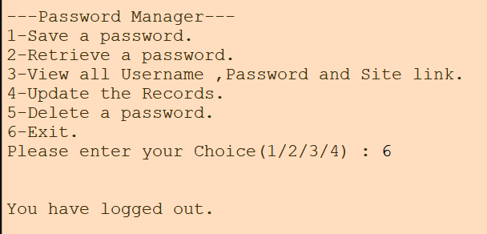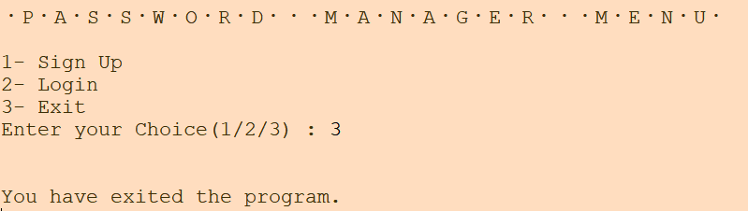

BIBLIOGRAPHY

This project wouldn’t have been a success without the below mentioned sources which acted as a tremendous stream of help to me

- Computer Science-Textbook for Class XII-NCERT

- Textbook for CBSE Class XI Computer Science with Python -Preeti Arora

- Python MySQL-GeeksforGeeks
https://www.geeksforgeeks.org/python-mysql/

- GEEKSFORGEEKS-Python GUI-tkinter
www.geeksforgeeks.org/python-gui-tkinter

